Press Release | 11 November 2016
The Theatre Night is preparing discussions, guided tours, autograph sessions and games

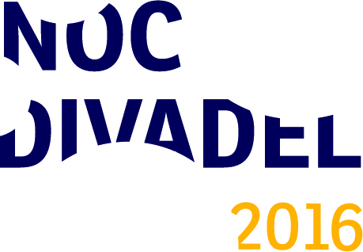
The Theatre Night, which is going to take place on Saturday, November 19 in the Czech Republic, offers a special program made only for this day. More than 100 theatres and theatre companies, libraries and cultural institutions from 35 Czech, Moravian and Silesian towns are going to participate in the event this year. The Arts and Theatre Institute, the coordinator of the program, is going to take part as well.
The project employs theatres as well as other cultural organizations. The Municipal Library in Prague prepared performances for children, stage reading, art workshop and a photo studio, in which the viewers can take photos in theatre costumes. Václav Havel Library invites the viewers to the performance of two plays by Havel – a students’ production of a microplay Ela, Hela and the Hitch and there will be screening of the production of the play Temptation from 1988. The coordinator of the fourth Theatre Night, the Arts and Theatre Institute, is going to participate in the program, too. It is preparing commentated tours, an improvised second hand bookshop and a bookshop, in which you can buy books with 10 per cent discount. There will also be a workshop of theatre photography and a photo competition. An adventurous game is going to be prepared for parents and their children.
The program of the Theatre Night is varied. Apart from theatre performances, there will be backstage guided tours, which are prepared by the majority of theatres. Theatres in the Czech Republic are preparing an unusual and interesting program. The J. K. Tyl Theatre in Pilsen prepared an autograph session of the ballet company dancers. Visitors can experience an adventurous street game with the Lampion Theatre in Kladno. The National Theatre in Prague invites the viewers to an interactive tour and videowalk Play Maeterlinck and the Municipal Theatres of Prague organize a charity auction of objects donated by the actors for the Světluška project. The performance and an accompanying program with medical clowns are going to be located in Palác Akropolis and the viewers can proceed to a discussion about art and its social overlap in the ALTA Studio.
The program of the Theatre Night is often accessible for free or with a lower price of entrance fee. In some cases, it is necessary to make a reservation in advance due to the capacity. We advise the viewers to go to our website www.nocdivadel.cz with the complete program of the event.
Contact for media
Adéla Vondráková
International Coperation and PR Department
Arts and Theatre Institute
T +420 224 809 196
M +420 776 752 432
E adela.vondrakova@divadlo.cz
www.idu.cz

