Press Release | 29 September 2016
The third Saturday in November belongs to the Theatre Night

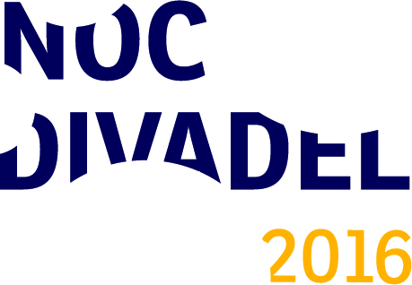
This year’s Theatre Night falls on 19 November and will be just as good as the last year’s night. Theatre and theatre companies in the Czech Republic invite the viewers to unusual theatre experiences, which will not repeat in the foreseeable future. The project is coordinated by the Arts and Theatre Institute.

Preparations for the fourth Theatre Night, the greatest theatre holiday of its kind in Europe, are culminating. The year 2016 traditionally brings about unusual theatre experiences and events, which are prepared exclusively for the Theatre Night and do not take place within the season. Last year’s Theatre Night provided the opportunity to participate in workshops, backstage guided tours, discussions with actors, stage designers and directors, or to take part in interactive performances. Theatres are still in the process of registering and this year’s program is in progress. However, it is clear not that traditional participants in the Theatre Night welcome several new institutions - Studio Dva and Black-light theatre METRO in Prague, International Conservatory Prague, Radost Theatre Brno, theatre company Jiří Poděbrady and the Art Museum Olomouc – Music Theatre. The program of this year’s Theatre Night is going to be published online gradually since 24 October at www.nocdivadel.cz.
Last year’s Theatre Night attracted 50,000 viewers, who paid a visit to some of 130 participating theatres and theatre companies in the Czech Republic in 36 Czech towns. The third Theatre Night surpassed all the previous ones, speaking of the participation of the whole republic. The Theatre Night is now established as a project with a nationwide impact.
In 2015, an extensive questionnaire focused on the Theatre Night and theatre audience in general was performed by the NSM Market Research. The outputs of the questionnaire are provided to theatres participating in the Theatre Night and they are published on the website of the Theatre Night. The tentative results of this year’s questionnaire say that the Theatre Night motivates the audiences to visit the theatre again: about 80 per cent of viewers are planning to visit a specific theatre again. 90 per cent of viewers also said they liked the Theatre Night. The outputs of the questionnaire will also function as an incentive for the offer of theatres to be more welcoming to the audience and reflect their wishes.
The Czech Theatre Night is a part of the international project European Theatre Night. The alleged initiator of the idea of a joint theatre festival, which has spread to more than ten countries in Europe, is Children’s Theatre Dubrava, which organized the debut Noc Kazališta on 25 October 2008 together with the Šibenik Theatre. Thanks to the participation of more than 50,000 viewers in each of the past two years, the Czech Theatre Night is the biggest project of the European Theatre Night.
Contact for media
Adéla Vondráková
International Cooperation and PR Department
Arts and Theatre Institute
T +420 224 809 196
M +420 776 752 432
E adela.vondrakova@divadlo.cz
www.idu.cz

